GR Pumps

1] main page for products
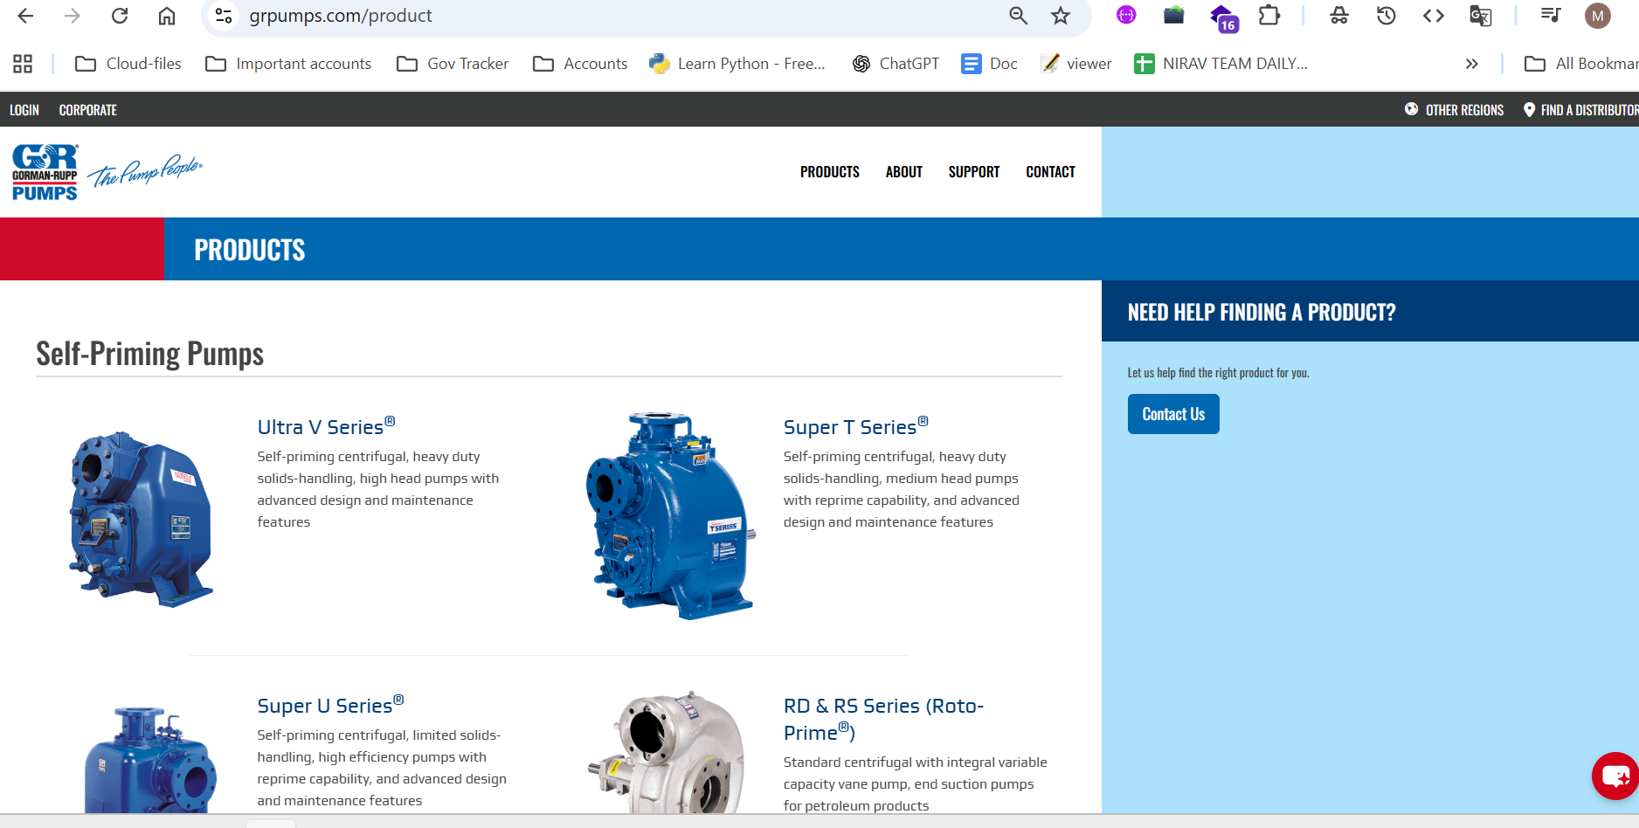
2] pdp page
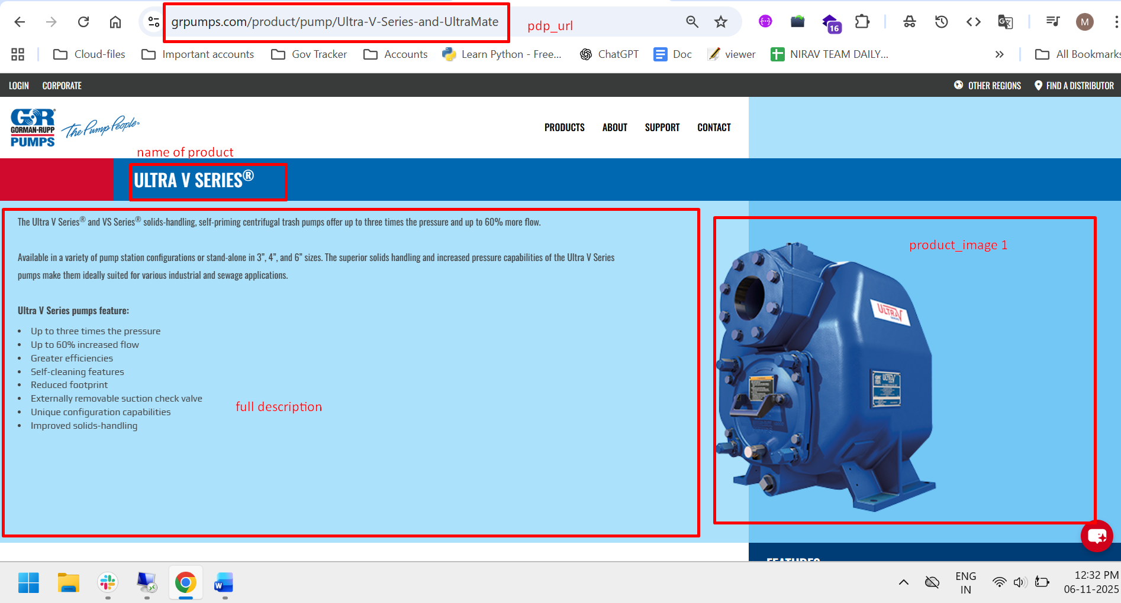
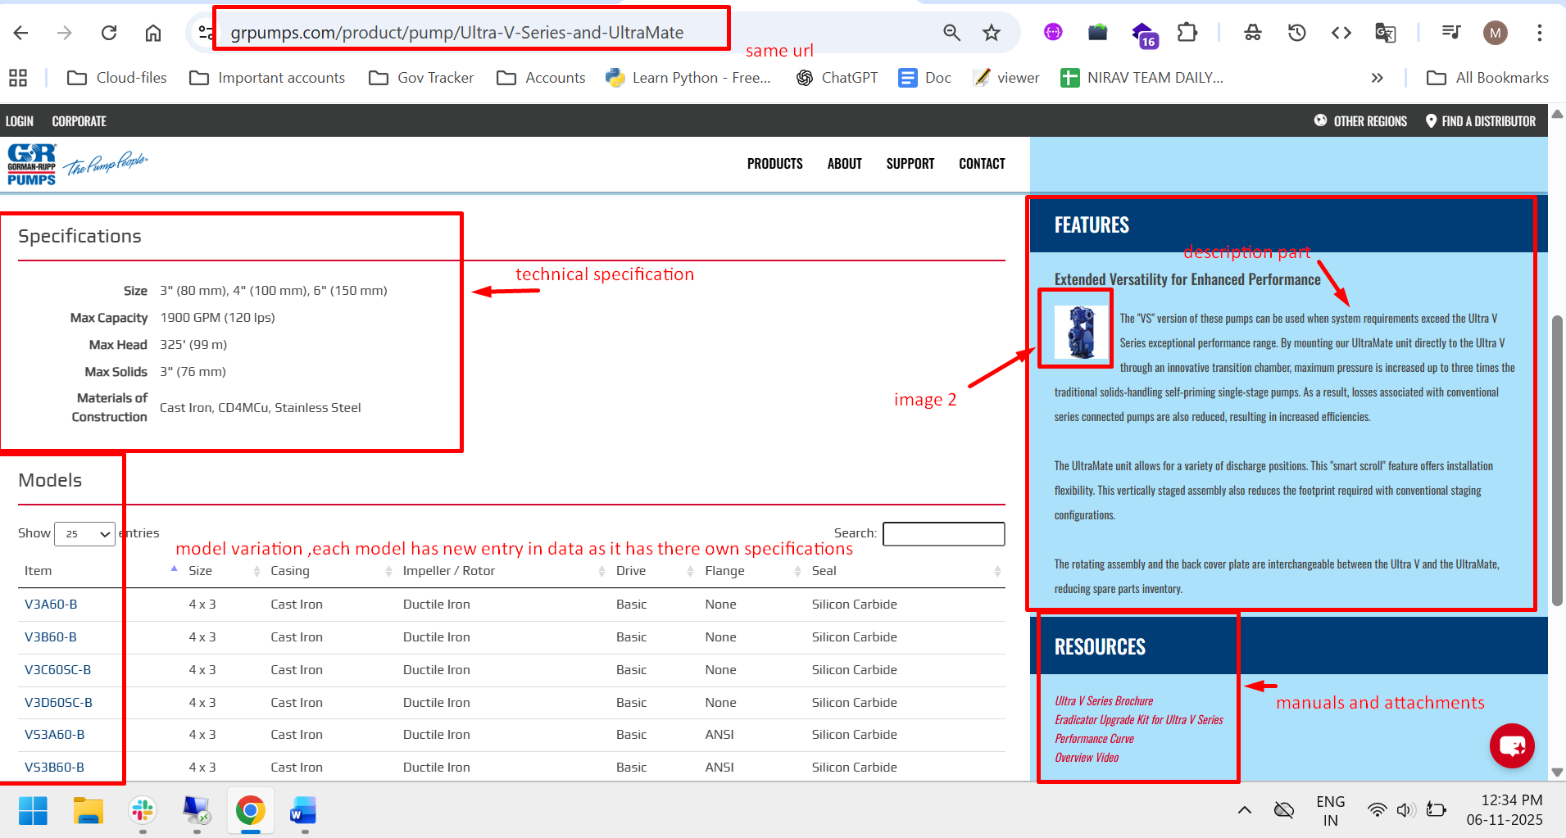
Main _pdp_utl = https://www.grpumps.com/product/pump/Ultra-V-Series-and-UltraMate
Variation url =https://www.grpumps.com/product/pump_model/Ultra-V-Series-and-UltraMate/V3A60-B
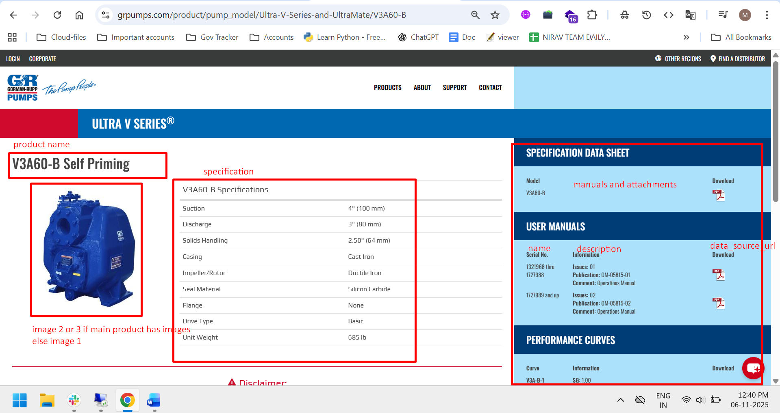
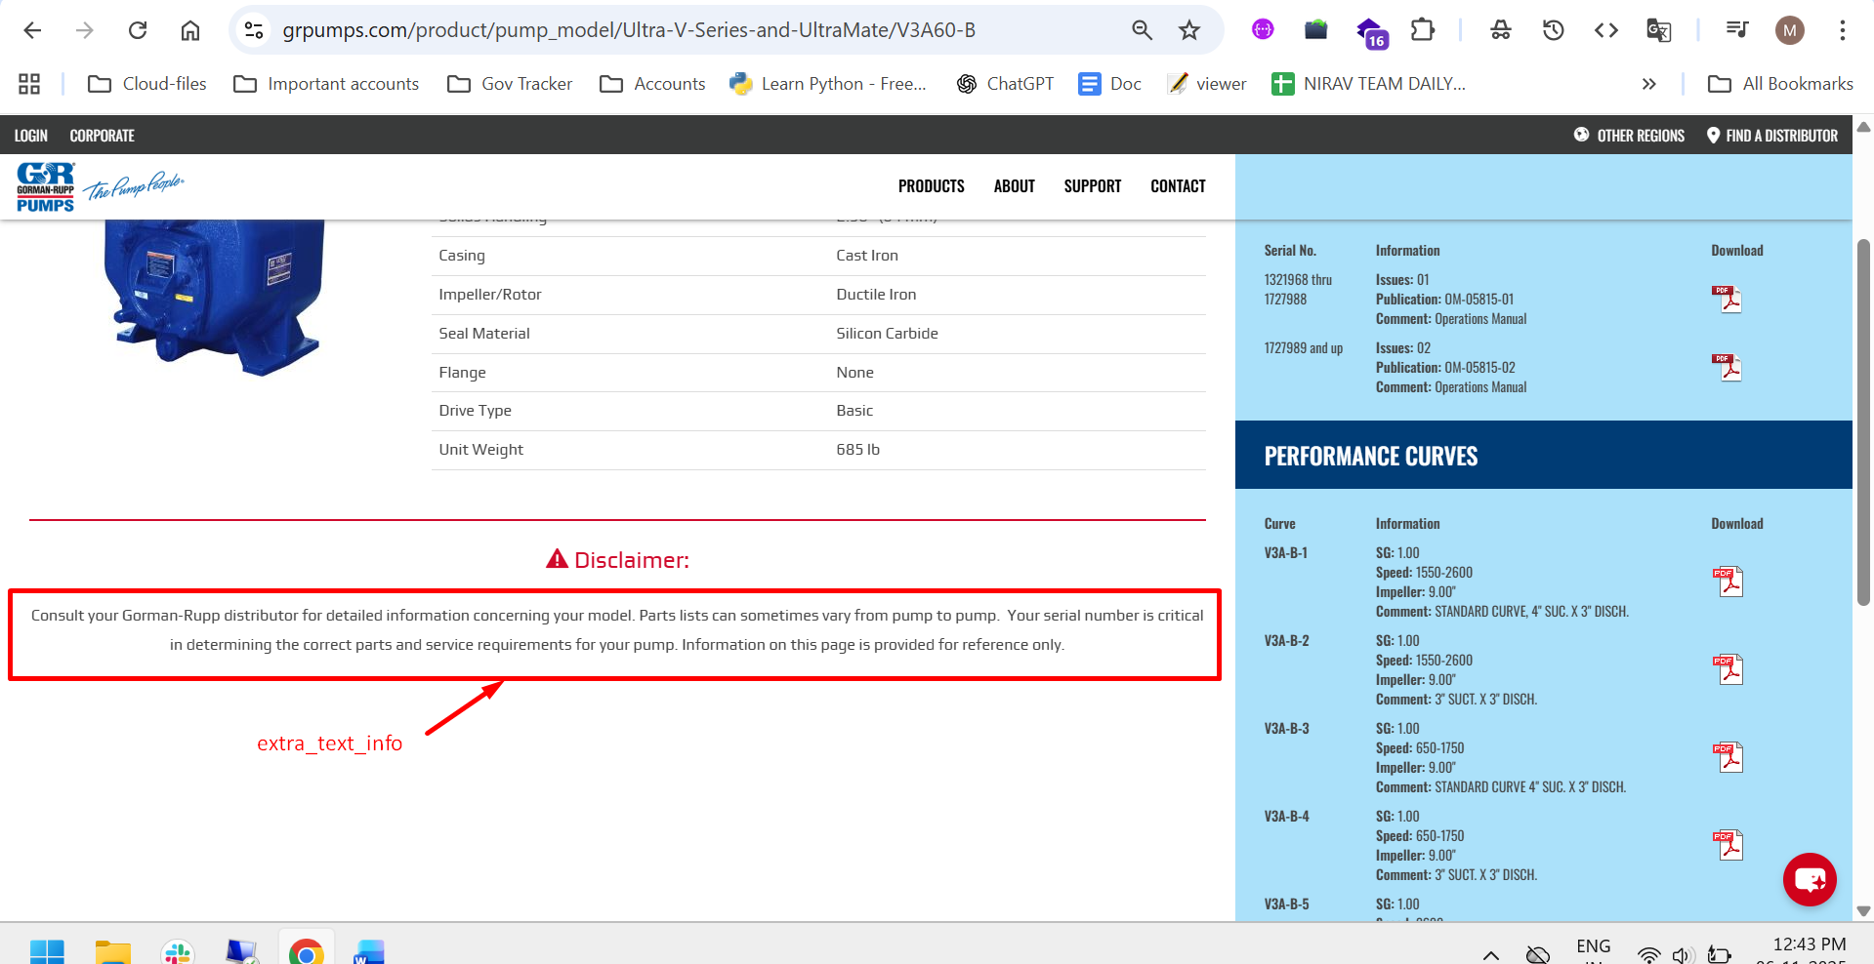
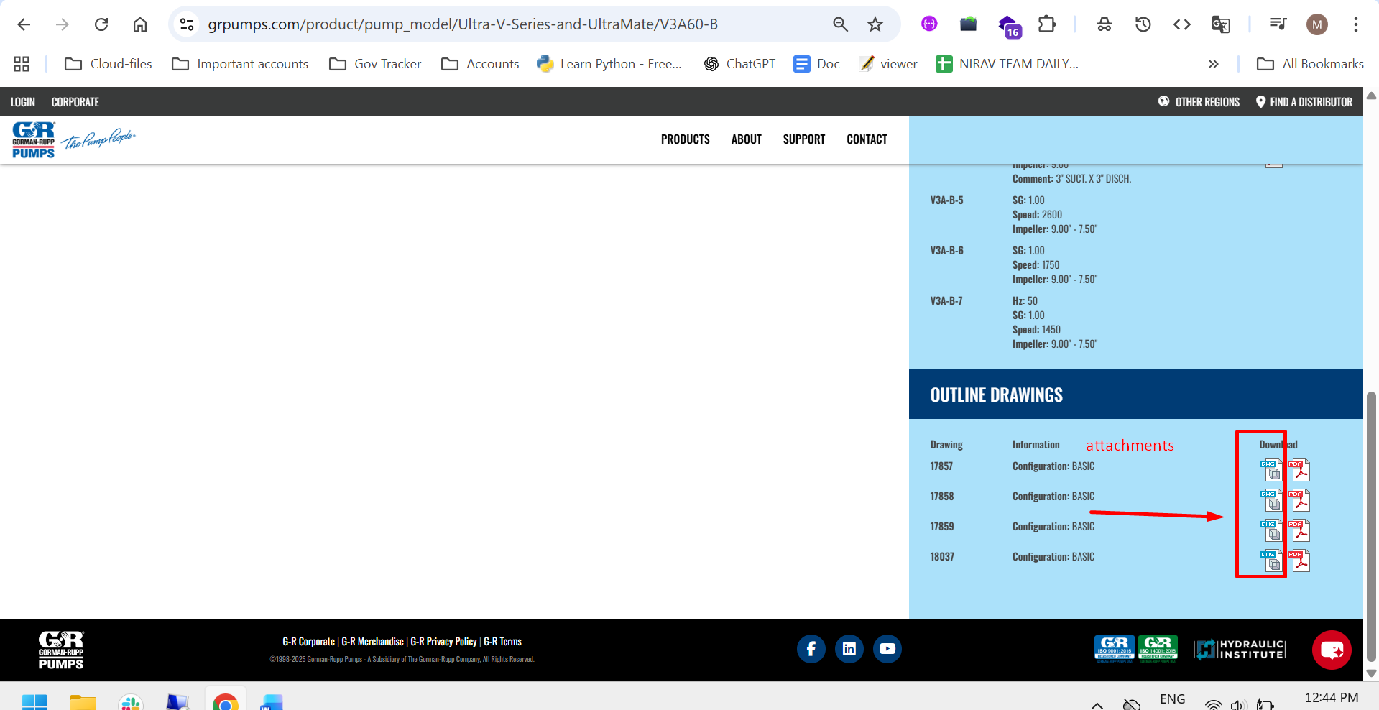
attachment = ['.dwg','.gif', '.jpg', '.jpeg', '.png', '.mp4', '.mov', '.avi', '.zip', '.stp','.x_t']
manual = ['.pdf', '.doc', '.docx']
# manufacturer
manufacturer= {"name":"Gorman-Rupp Pumps",
"description": "©1998-2025 Gorman-Rupp Pumps - A Subsidiary of The Gorman-Rupp Company, All Rights Reserved.",
"website": "https://www.grpumps.com/",
"logo_url": "https://www.grpumps.com/img/pump_group/GR_logo-base_PP.png",
"founded_year": 1933,
"headquarters": "Mansfield, Ohio, USA"}
each filed data type check in SOW

